## Notes

* For a function to be considered sequence, its domain must be in natural numbers.
* If the limit of a function from the left side is different than the right side, then limit doesn’t exist
* If the left-hand limit and right-hand limit of a function exist and are equal, then the limit exists and is equal to either.
* Inverse of a non-differentiable function is also not differentiable

## Some limits

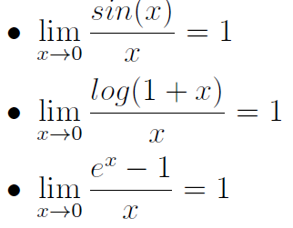

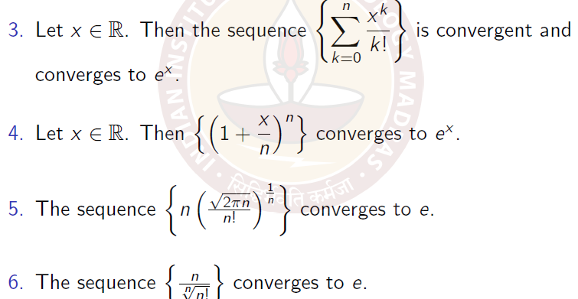

Useful rules regarding convergence of sequences

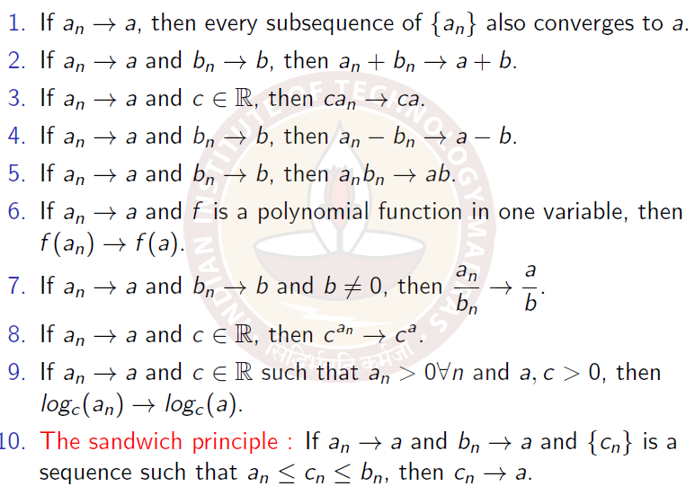

## Continuity

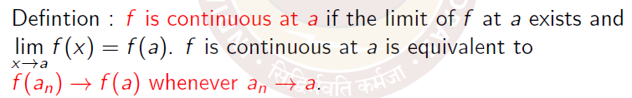

## Equation of the tangent (Linear approximation)

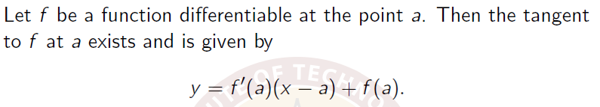

Examples follow:

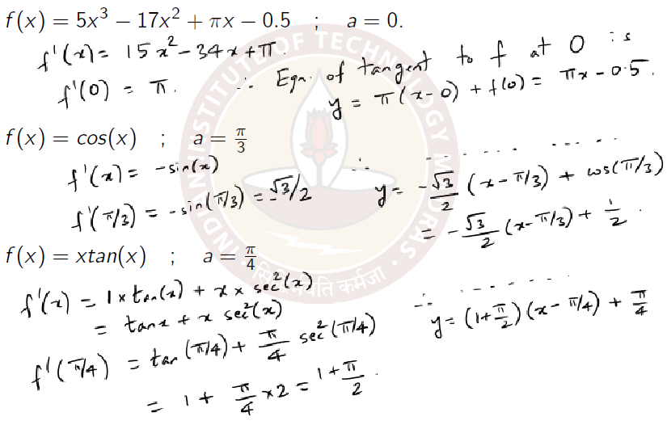

## Critical points

A point a is called a critical point of a function f(x) if either f is not differentiable at a or f’(a)=0

Every turning point is a critical point, but converse is not true. Critical points include saddle points also. Include local extrema of a function f on a closed interval I = [a, b]. Thus, to find the maximum and minimum, we find the critical points and the boundary points and check the value of f on all of

them.

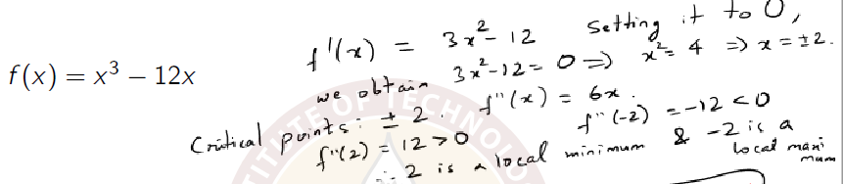

## Reimann sum

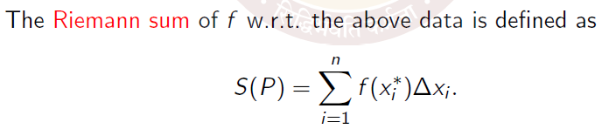

## Fundamental theorem of calculus

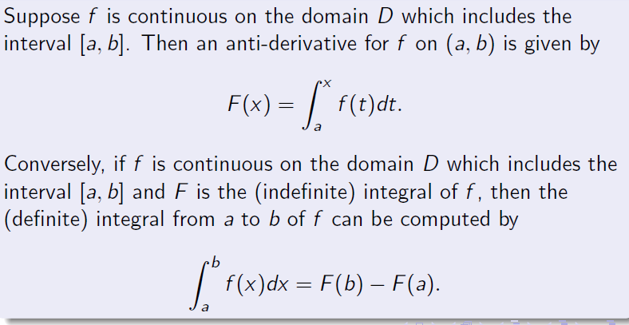

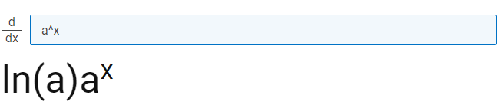

## Some common integrals

